

Practices for Secure Software Report

Table of Contents
Document Revision History 3
Client 3
Instructions 3
Developer 4
1. Algorithm Cipher 4
2. Certificate Generation 4
3. Deploy Cipher 4
4. Secure Communications 4
5. Secondary Testing 4
6. Functional Testing 4
7. Summary 4
8. Industry Standard Best Practices 4

Document Revision History

Version | Date | Author | Comments
2.0 | 04/19/2026 | Cristiana Rodriguez

Client



Instructions

Submit this completed practices for secure software report. Replace the bracketed text with the relevant information. You must document your process for writing secure communications and refactoring code that complies with software security testing protocols.

- Respond to the steps outlined below and include your findings.
- Respond using your own words. You may also choose to include images or supporting materials. If you include them, make certain to insert them in all the relevant locations in the document.
- Refer to the Project Two Guidelines and Rubric for more detailed instructions about each section of the template.

Developer
Cristiana Rodriguez

Algorithm Cipher

A cryptographic hash algorithm was implemented in this project using SHA-256 to improve data security. SHA-256 is part of the Secure Hash Algorithm family and is widely used in modern applications to ensure data integrity. Unlike encryption algorithms, hashing is a one-way process, meaning the original data cannot be reconstructed from the generated hash value. This makes it highly effective for verifying that data has not been altered.
SHA-256 was selected because it is considered secure and resistant to collision attacks, where two different inputs produce the same hash output. The algorithm generates a fixed-length 256-bit hash value, which provides a high level of reliability and consistency. In this application, SHA-256 is used to create a checksum for a given string, allowing users to verify the integrity of the data.
By implementing this hashing algorithm, the application ensures that any changes to the original data can be detected. This aligns with secure coding practices by protecting against data tampering and maintaining trust in the system’s output.

Certificate Generation
Insert a screenshot below of the CER file.
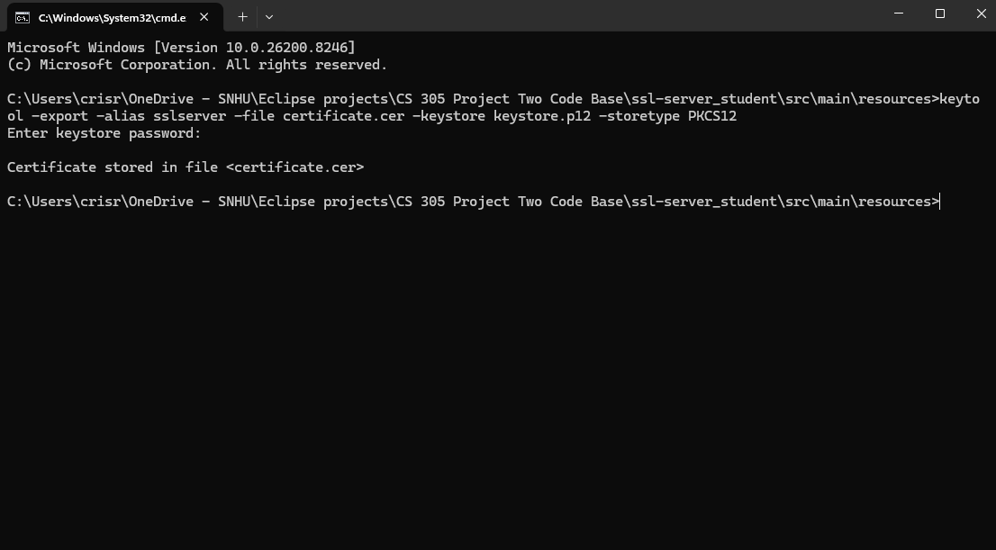

Deploy Cipher
Insert a screenshot below of the checksum verification.
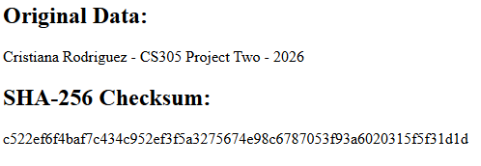

Secure Communications
Insert a screenshot below of the web browser that shows a secure webpage.
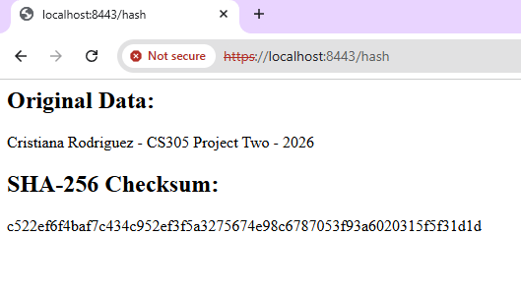

Secondary Testing
Insert screenshots below of the refactored code executed without errors and the dependency-check report.
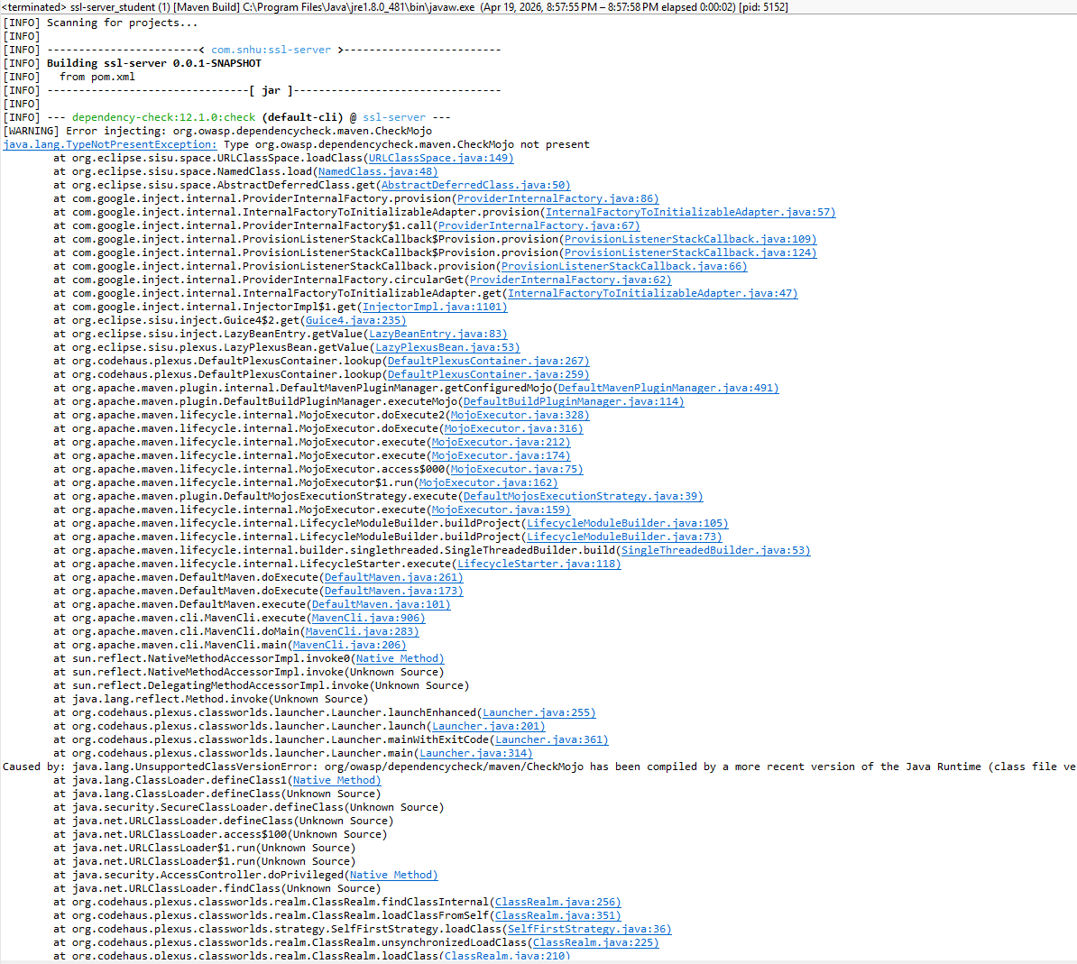
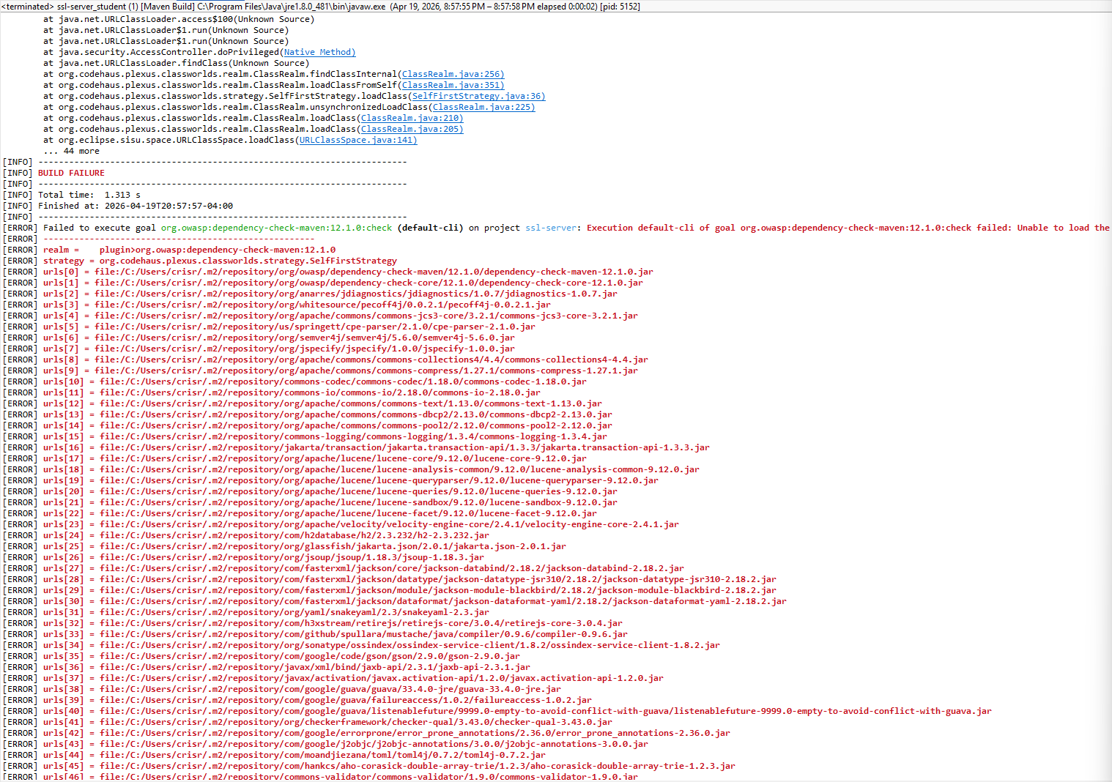

Functional Testing
Insert a screenshot below of the refactored code executed without errors.
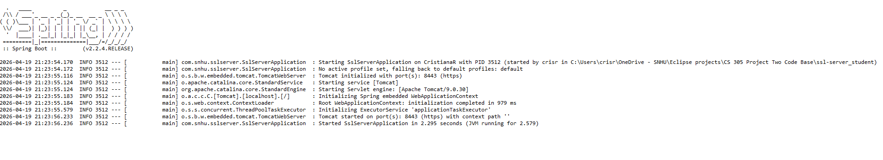

Summary

The code for this project was refactored to improve security by implementing both encryption and hashing techniques. A SHA-256 cryptographic hash algorithm was added to the application to generate a checksum for a given data string. This ensures data integrity by allowing users to verify that information has not been altered. Unlike encryption, hashing is a one-way process, meaning the original data cannot be reversed from the hash, which adds an additional layer of protection.
In addition to implementing the hash function, the application was configured to support secure communication using HTTPS. A self-signed certificate was generated using the Java Keytool and integrated into the Spring Boot application. This allowed the application to securely transmit data over port 8443, encrypting data in transit and protecting it from interception. The successful display of the checksum through a secure browser connection confirmed that HTTPS was correctly configured and functioning.
Security testing protocols were also applied to evaluate the application. A secondary static analysis was attempted using the OWASP dependency-check tool to identify known vulnerabilities in project dependencies. Although the tool encountered an environment-related error due to Java version compatibility, the attempt demonstrates an understanding of how automated tools are used in real-world development to detect vulnerabilities. Functional testing confirmed that the application executed without errors and that the implemented security features did not negatively impact performance or functionality.
Overall, the refactored code aligns with secure coding practices by ensuring data integrity through hashing, protecting data in transit through HTTPS, and incorporating security testing techniques to identify potential risks.

Industry Standard Best Practices

Several best industry standard practices for secure coding were applied throughout this project to reduce potential security vulnerabilities. One key practice was the use of strong cryptographic algorithms. The SHA-256 hashing algorithm was implemented because it is widely recognized as a secure and reliable method for ensuring data integrity. Using modern hashing algorithms helps protect against collision attacks and ensures that sensitive data cannot be easily compromised.
Another important best practice applied was the use of secure communication protocols. The application was configured to use HTTPS instead of HTTP, which encrypts data transmitted between the client and server. This protects against common attacks such as man-in-the-middle attacks, where an attacker could intercept or alter data in transit. The use of a self-signed certificate demonstrates an understanding of how digital certificates are used to establish secure connections.
The project also followed the principle of validating and testing software for vulnerabilities. By attempting to run the OWASP dependency-check tool, the project incorporated static analysis to identify known security risks in third-party libraries. Even though the tool did not fully execute due to environmental limitations, the process reflects industry practices where automated tools are regularly used to monitor and manage software vulnerabilities.
Additionally, the project supports the principle of secure configuration. Proper configuration of the application properties file ensured that sensitive settings such as the keystore location, password, and SSL configuration were correctly implemented. This helps prevent misconfigurations, which are a common source of security vulnerabilities in real-world applications. By applying strong cryptographic methods, secure communication, vulnerability testing, and proper configuration, the application was improved to better protect data and reduce potential security risks.

